Chapter 2 p.20

Countries targeted by the top four ransomware variants

The regional presence of ransomware was an indication of targeted attack and encryption by the threat actors.

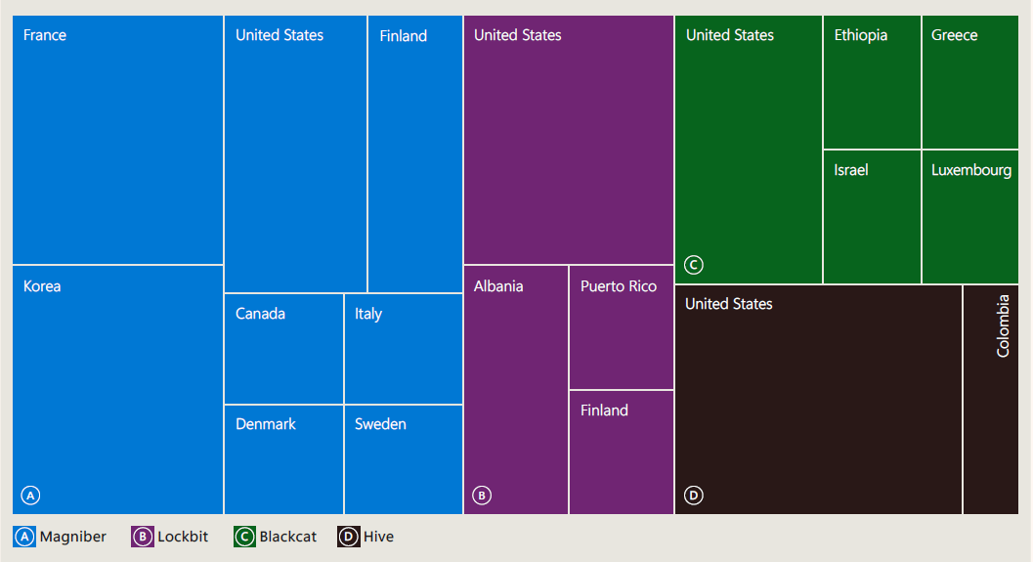

Diagram showing Countries targeted by the top four ransomware variants. Magniber targets France, United States, Finland, Italy, Canada, Denmark, Sweden, and Korea; Lockbit targets United States, Albania, Puerto Rico, and Finland; Blackcat targets United States, Ethiopia, Greece, Israel, and Luxembourg; and Hive targets United States and Colombia.

Source: Microsoft Defender Experts notifications